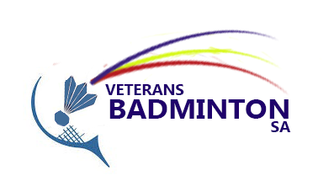  BVASA 2023 November Tournament  Saturday 11th & Sunday 12th November  At  WA Satterley Hall  42 Rutland Avenue, Lockleys  Return completed entry form with payment to:  The Secretary, Email - secretary@bvasa.org  Bank deposit/electronic transfer BSB: 015210 A/C: 615002715  Use your name as reference and send email to advise of transfer.  Or hand to one of our committee members  ENTRIES CLOSE - FRIDAY 27th October 2023  Enquiries to:  Allen Slack 0406 389 767  John Brodie 0409 096 640  Ingrid Chisholm 0419 034 360 |  | This tournament is open to all members of the BVASA. As usual the emphasis will be on enjoyment as well as competitive badminton.  Players should enter as individuals, as teams will be arranged by the Match Committee.  The tournament fee is $20. Payment is required at the time you lodge your entry form, either with a committee member or email to the Secretary, with banking details attached.  Anticipated playing times are:  Saturday 9.00am - 5.00pm  Sunday 9.30am - 1.00pm  Players participate at their own risk.  Canteen  Food and refreshments will be available at the canteen throughout the weekend.  Barbecue  We will also supply a BBQ with BYO drinks after play on Saturday night if we get sufficient interest. Please let us know if you are interested in participating. Members $5, Non-members $8
Name | Entry | BBQ | Total
Male | $20 | $ | $
Female | $20 | $ | $

